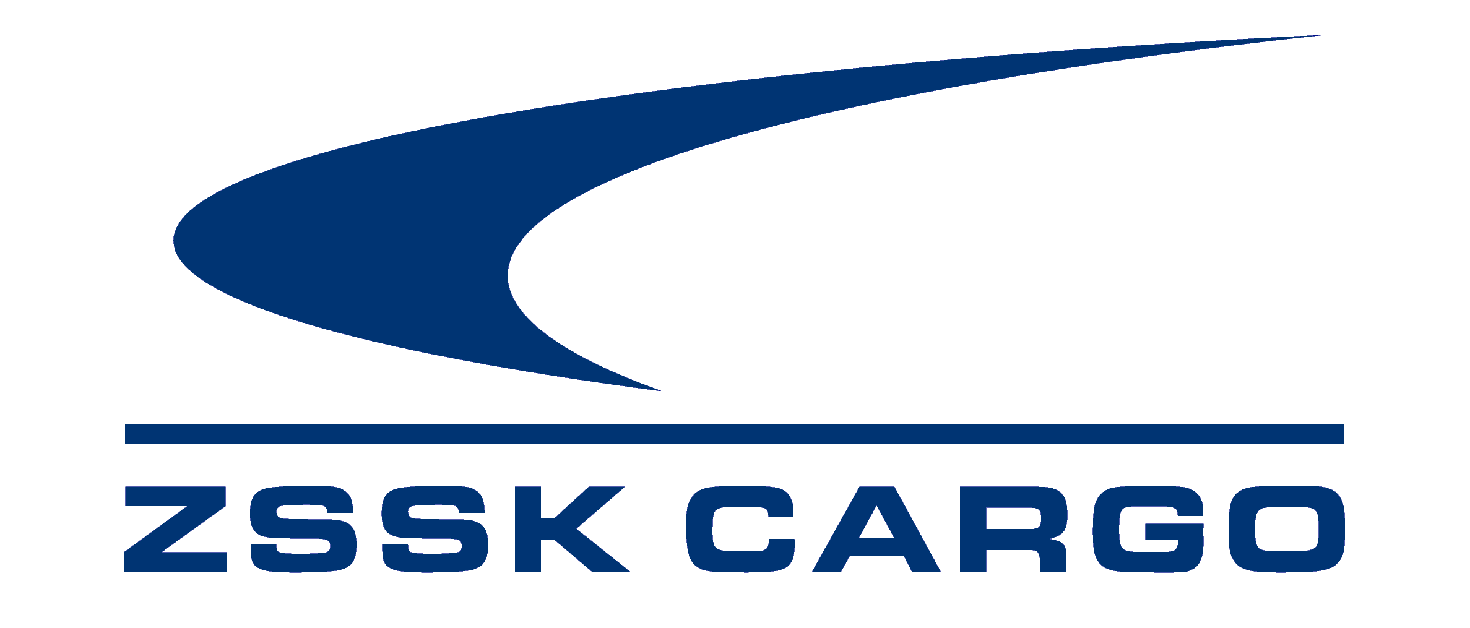

Železničná spoločnosť Cargo Slovakia, a.s.
Rolling stock services Division
Tomášikova 28B, SK-821 01 Bratislava
Slovak Republic

Registration number: Bratislava, date:

C E R T I F I C A T E
o f q u a l i f i c a t i o n

i s s u e d

pursuant to the Qualification Screening Directive 3_U40_Smernica-15_2017_v1.1, by the Rolling stock services Division.

The supplier is qualified to supply products to Železničná spoločnosť Cargo Slovakia, a.s. in the following fields of activity:

This Certificate is valid until:

......................................
stamp
......................................
Dipl. Ing. Ľubomír Kuťka
Member of Board of Directors and
Director of Rolling stock services Division

Conditions:

The specified activities must by performed with respect and adherence to the provisions of valid regulations of Železničná spoločnosť Cargo Slovakia, a.s., UIC regulations, relevant technical norms and technical documentation, as well as the requirements of law.

In case of extension or change of the activities or of the cooperation, the supplier must immediately notify the Certificate issuer about such change.

If the supplier has carried out low-quality work or repeated non-compliance with the subject of the activities, the issuer of the Certificate reserves the right to carry out special screening of the supplier, possibly modify the scope of the assessed activities, or cancel the validity of this Certificate during its period of validity.

The issue of this Certificate does not represent that the evaluated company will automatically become a supplier of Železničná spoločnosť Cargo Slovakia, a.s.

The supplier must request possible prolongation or re-issue of the Certificate two months before its validity has expired.

Železničná spoločnosť Cargo Slovakia, a.s.
Rolling stock services Division
Tomášikova 28B, SK-821 01 Bratislava
Slovak Republic

Registration number: Bratislava, date:

Annex to the certificate of quality issued

pursuant to the Qualification Screening Directive 3_U40_Smernica-15_2017_v1.1, by the Rolling stock services Division.

The supplier is qualified to supply products to Železničná spoločnosť Cargo Slovakia, a.s. in the following fields of activity:

......................................
Dipl. Ing. Ľubomír Kuťka
Member of Board of Directors and
Director of Rolling stock services Division

......................................
stamp

Conditions:

The specified activities must by performed with respect and adherence to the provisions of valid regulations of Železničná spoločnosť Cargo Slovakia, a.s., UIC regulations, relevant technical norms and technical documentation, as well as the requirements of law.

In case of extension or change of the activities or of the cooperation, the supplier must immediately notify the Certificate issuer about such change.

If the supplier has carried out low-quality work or repeated non-compliance with the subject of the activities, the issuer of the Certificate reserves the right to carry out special screening of the supplier, possibly modify the scope of the assessed activities, or cancel the validity of this Certificate during its period of validity.

The issue of this Certificate does not represent that the evaluated company will automatically become a supplier of Železničná spoločnosť Cargo Slovakia, a.s.

The supplier must request possible prolongation or re-issue of the Certificate two months before its validity has expired.

